L 12. Emotional intelligence and conflict management

Organizational conflict
Pondy conceptualized a model of organization conflict and identified conflict as a “(1) bargaining conflict among the parties to an interest group relationship, (2) bureaucratic conflict between the parties to a superior–subordinate relationship, and (3) system conflict among parties to a lateral or working relationship” (Pondy, Citation1967, p. 297). Pondy also stated that three conflicts should be treated as a series of episode, where there were five stages of a conflict episode, namely, (1) latent conditions; (2) perceived conflict (cognition); (3) felt conflict (affect); (4) manifest conflict (behavior); and (5) conflict aftermath (conditions) (Figure 1).
Figure 1. The dynamic of a conflict episode (Pondy, Citation1967, p. 306).

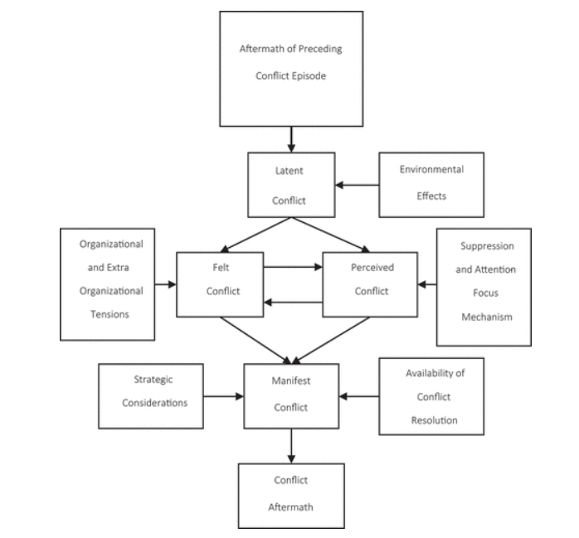
Early organizational conflict theorists found that conflict is detrimental to organizational functioning and tended to focus on the causes and resolution of conflict (Jehn, Citation1995). Research on conflict management between 1997 and 2006 began to focus on workplace conflict and conflict management styles, cultural differences in conflict management, and group conflict and work performance (Zhenzhong Ma et al., Citation2008). Furthermore, Caputo et al. (Citation2019) showed in a study of conflict management between 2007 and 2017 that the focus of conflict management tended to address topics, such as gender, emotion, and power in negotiations, culture and conflict management styles, trust and cooperation, mediation and social conflict, and performance and governance. Conflict was no longer seen to be totally dysfunctional, but something that needed to be managed through negotiation or structural adaptation (Nair, Citation2008).
Type of conflicts
Task, relationship, and process conflict
Priem and Price (Citation1991) classified two types of conflict: cognitive, task-related conflicts and social-emotional conflicts. In addition, Jehn examined and defined three types of organizational conflict: “relationship conflicts focused on interpersonal relationship, task conflicts focused on the content and the goal of the work, and process conflicts focused on how tasks would be accomplished” (Jehn, Citation1997, p. 550) (see Figure 2). Results suggested that process and relationship conflicts were negatively associated with individual satisfaction and group performance; while task conflict was positively associated with group performance. Whether these types of conflicts were beneficial or detrimental depended on the type of conflict, the structure of group, task interdependence, and group norms. It is also acknowledged that task conflict can improve organization performance (Bourgeois, Citation1985; Eisenhardt & Schoonhoven, Citation1990), decision-making outcomes, and group productivity (Amason, Citation1996). Chronic relationship conflicts can have serious detrimental effects on group functioning, and especially so in conflict where the conflict is negative, petulant, untrustworthy, frustrated, and hateful. For example, if group members disagree on tasks, they will dislike other members and associate this task-related conflict with personality issues (Jehn, Citation1997).
Figure 2. A model of group conflict and performance, Jehn (Citation1997, p. 552).
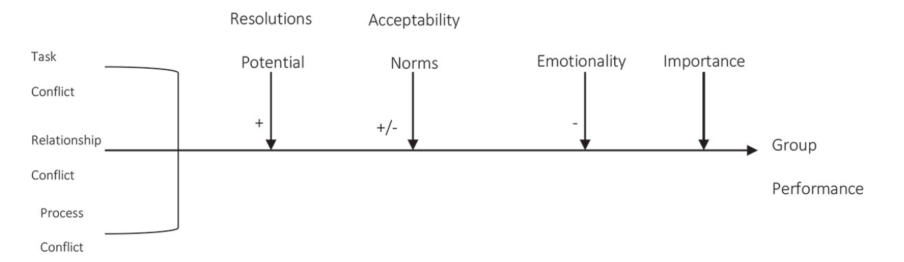

Customer conflict
Furthermore, conflict does not only impact upon interrelationships within organizations (e.g., between employees and management, co-workers), but also can occur in relationships between employees and customers, known as customer conflict. Service employees regularly deal with customers and they deliver service according to the customers’ requirements. Unpleasant interactions between the service provider and customers can often occur. Service employees are often confronted with inappropriate customer behavior and attitudes, known as customer-related social stressors (CSS) (Beitler et al., Citation2016; Dormann & Zapf, Citation2004).
Dormann and Zapf classified CSS as “disproportionate customer expectations refer to customers’ behaviors and attitudes, which challenge acceptable service expectations from the service employee’s point of view. Verbally aggressive customers criticize and verbally attack service employees. Disliked customers refer to unpleasant, humorless and hostile customers. When being confronted with ambiguous customer expectations, it is unclear to the service employee what the customer wants” (Dormann & Zapf, Citation2004, pp. 69–70). Consequently, this situation will have negative impacts on service employees’ emotional health such as burn out and stress in the workplace (Beitler et al., Citation2016; Grandey et al., Citation2004)
Work–family conflict
Besides interpersonal and customer conflict, conflict may occur and can impact on employees’ family, as conflict has a dyad relationship where work and family are the most dominant life domains (Michel et al., Citation2011). Researchers over the decades have focused attention on the two domains. Conflict is known to have a negative impact on individual performance, for example, depression, hypertension, and abuse (Burke & Greenglass, Citation1999; Frone, Citation2000) and important organizational performance measures, such as absenteeism, commitment, and turnover intentions (Greenhaus et al., Citation2001; Kossek & Ozeki, Citation1998).
Greenhaus and Beutell have defined work–family conflict as “a form of inter-role conflict in which the role from the work and family domains are mutually incompatible in some respect” (Greenhaus & Beutell, Citation1985, p. 77). The contemporary work–family construct reveals two primary characteristics. First, these role pressures are directional and produce negative effects from one domain to the other–namely, work-to-family conflict (WFC), in where participation in the family role is made difficult because of participation in the work role and family-to-work conflict (FWC) in where participation in the work role is made more difficult from participation in the family role. Secondly, family conflict is generally seen as time-based, strain-based, and behavior-based (Greenhaus & Beutell, Citation1985). Time-based conflict occurs when time or attention allocated to one domain, such schedule inflexibility and work or family time demands, hinders role performance in the other. Strain-based conflict occurs when increased stress or tension in one domain, such as role ambiguity or role overload, hinders role performance in the other domain. Behavior-based conflict occurs when behaviors are transferred from one domain to another, such as behavioral habits and role expectations may hinder performance in the other domain. The summary of the different types of conflict is presented below (Table 1).

Author(s) | Type of conflicts
Pondy (Citation1967) | - Bargaining Model  - Bureaucratic Model  - Systems Model
Wall and Nolan (Citation1986) | - Relationship-focused people conflicts  - Conflicts about the substantive content of the task
Priem and Price (Citation1991) | - Cognitive, task-related conflicts  - Social-emotional conflicts
Jehn (Citation1995) | - Relationship conflict  - Task conflict
Jehn (Citation1997) | - Relationship conflict  - Task conflict  - Process conflict
Michel et al. (Citation2011) | Work family conflict  - Work to family conflict  - 2. Family to work conflict
Dormann and Zapf (Citation2004) | Customer related social stressor (customer conflict)  1. Disproportionate customer expectations  2. Verbally aggressive customers  3. Disliked customers  4. Ambiguous customer

Conflict management style
Over the past decades, literature in conflict management has become more expansive. Researchers have examined the distinction between the type of conflict management style (CMS) and tactics. In addition, empirical studies have explored preferred conflict management styles and their impacts on organization and job performance (Zhenzhong Ma et al., Citation2008). Conflict management style (CMS) or resolutions have been described as specific behavioral patterns that individuals prefer to use when dealing with conflict (Caputo et al., Citation2018). Thomas and Schimidt have defined “conflict as a process that begins when one party perceives the other has frustrated, or is about to frustrate, some concerns of his studies have used these styles to identify different CMS in order to achieve appropriate conflict management” (Thomas & Schimidt, Citation1976, p. 315). An empirical study (Ma et al., Citation2008) suggested that the Rahim’s five-style model (Rahim, Citation1983) appears to be the most valid. Rahim (Citation1983) proposed there were five approaches to CMS or conflict resolution styles and conflict-handling: integrating, avoiding, obliging, dominating, and compromising. This model is used to differentiate styles of handling interpersonal conflict in two dimensions: concern for self and concern for others. Rahim extended the definition of “conflict to an interactive process manifested in incompatibility, disagreements, or dissonance within or between social entities (i.e. individual, group, organization)” (Rahim & Psenicka, Citation2002, p. 207). Conflict management styles from this dual concern model have been classified as (1) dominating: high concern for self and low concern for the other or task; (2) obliging: low concern for self and high concern for the other; (3) avoiding: low concern for self and low concern for the other; (4) integrating: high concern for self and high concern for the other; and (5) compromising: moderate concern for self and moderate concern for the other (Figure 3).
Figure 3. The style of handling interpersonal conflict, Rahim (Citation1983, p. 369).

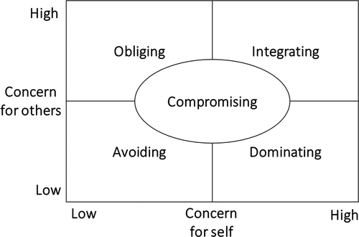
Emotions in organization
When considering emotions in organizations, Nadler and Lowery stated that “emotions are behaviors that express feelings towards a triggering object” (Nadler & Lowery, Citation2009, p. 24). Emotions can be experienced either internally or externally (Nadler & Lowery, Citation2009) by individuals in the organization and the individual’s emotions can be contagious. These emotions can be managed by the individual’s EI to the benefit of organizations (Menges, Citation2012). Goleman (Citation1998) indicates that a business leader needs an intuition and the ability to know people’s emotions and respond in an appropriate way. Researchers from Western countries view emotions as “irrational” and believe that conflict is bad or dysfunctional.
Bodtker and Jameson (Citation2001) stated that when conflict occurred in an organization, automatically emotions are involved. Mayer, Caruso, and Salovey have also stated that “emotions are interval events that coordinate many psychological subsystems including physiological responses, cognitions, and conscious awareness. Emotions typically arise in response to a person’s changing relationship” (Mayer et al., Citation2000, p. 267). EI is an ability to recognize the meaning of emotions and their relationships, and to reason, and problem solve. EI has significant potential as a required ability within workplace behaviors in organizations (Jordan & Troth, Citation2002).

Research locations and area and the research outcome
According to research locations, researchers in conflict management styles found that conflict management has a strong relationship with cultural studies, especially in the relationship between culture and EI in conflict management (Caputo et al., Citation2019). Some studies demonstrated that national regional cultures have an important role in conflict and have a significant effect on individual personalities and conflict resolution style. Shih and Susanto (Citation2010) found that the integrating style and the compromising style were used by Javanese people in the workplace. Sunindijo and Hadikusumo (Citation2014) found that in Thailand, people prefer harmony-enhancing and nonconfrontational styles.
Chen et al. (Citation2016) showed that Taiwanese people emphasize group values and harmonious relationships. People who live in these countries are influenced by a collectivism culture, where they prefer to maintain harmony and tolerate others. In contrast, people who live in developed countries have an individualist culture, which is expressed by independent group members, focus on the benefits and costs in a relationship, and prioritize personal needs rather than group needs (Komarraju et al., Citation2008).
In addition, the majority of the studies were conducted in education institutions. The concern of the study is about the equality of results obtained in a university and the workplace. These are the considerations in a university setting are (1) the team member has a short-term problem; (2) the conflict history is different; and (3) conflict in the workplace takes more time to escalate (Poitras, Citation2012).
This work has found that EI has a positive relationship with conflict management styles. Hopkins and Yonker (Citation2015) explained that the use of the conflict management style reduced task conflict, relationship conflict, and stress; and that the use of the dominating and avoiding style of conflict management increased task conflict, relationship conflict, and stress. Their study suggests that the integrative style of handling conflict which involves examining differences to reach a mutually acceptable solution is linked to two specific EI abilities: problem solving and social responsibility. Problem solving is a comprehensive ability in which a person recognizes and defines problems as well as generates and implements effective solutions. Social responsibility indicates that an individual is aware of and takes responsibility for the impact of their decisions and activities on others. Zhang et al. (Citation2015) stated that some emotions have a positive effect in conflict resolution.
Rahim and Psenicka (Citation2002) conducted a model of EI and conflict management style in seven countries (the USA, Greece, China, Bangladesh, Hong Kong, Macau, South Africa and Portugal). They found that EI is positively associated with problem solving strategies, which means that employees pursue their own and others’ concerns when handling conflict. In addition, in the work–family conflict context, emotionally intelligent employees have a more stable life, with less conflict and greater peace of mind. This indicates that there is a good relationship between co-workers and supervisors and a greater understanding of their feelings and emotions (Suliman & Al‐Shaikh, Citation2007). Leaders in organizations also have an important role in managing conflict in work teams, as Ayoko and Konrad (Citation2012) suggests that using leaders in emotion management lessened the negative effect of relationship conflict on team performance and eliminated the negative effect of relationship conflict on team morale.
Schlaerth et al. (Citation2013) investigated the relationship between EI and constructive conflict management, and their results demonstrated that EI is positively associated with constructive conflict management, which is stronger for subordinates than leaders. Shih and Susanto (Citation2010) also found that EI was positively and significantly associated with job performance and conflict management style (integrating style and compromising style). These findings have been supported by empirical evidence (Goleman, Citation1998; Mayer et al., Citation2000; Wong and Law, Citation2002; Jordan & Troth, Citation2002; Yu et al., Citation2006). Zhang et al. (Citation2015) also found that EI was significantly and positively related to conflict management style (integrating, compromising and dominating styles) and was an important predictor of employees’ innovation performance.
Conflicts in organizations
The present review reveals that task and relationship conflict can have positive and negative impacts on individual performance, group performance, and organization performance (Shih & Susanto, Citation2010; Zhang et al., Citation2015; Jordan & Troth, Citation2004; C. Lee & Wong, Citation2017). This work shows that the interpersonal conflict in organizations is conflicts among co-workers, co-workers and superiors, and employees and management (leadership) in organizations (Basogul & Ozgur, Citation2016; Chan et al., Citation2014; Kumari, Citation2015; Ma et al., Citation2019; Moeller & Kwantes, Citation2015; Morrison, Citation2008; Rahim & Psenicka, Citation2002; Rezvani et al., Citation2019; Suliman & Al‐Shaikh, Citation2007; Sunindijo & Hadikusumo, Citation2014; Tokakis et al., Citation2018; Yu et al., Citation2006).
Furthermore, work–family conflict also occurred in organizations that had impacts on job satisfaction, schedule flexibility satisfaction, and employee behavior in the workplace (Magnini et al., Citation2011; Suliman & Al-Shaikh, Citation2007). Unfortunately, this work did not find examples of interpersonal conflict between employees and customers in organizations as there is a lack of research that examines customer satisfaction in the context of organization conflict.
Although we identified the types of conflict that occurred in organizations, some of the studies did not measure or correlate the conflict management styles (CMS) with the types of conflict. The studies only used the scale of CMS to define which CMS was suitable for the conflict conditions in an organization. Most of the studies measured conflict management styles by using the Rahim Organizational Conflict model (Rahim, Citation1983) as the most valid measurement. Other measurements such as the work–family conflict developed by Kopelman et al. (Citation1983), relationship conflicts in a team (Pelled et al., Citation1999), the conflict resolution measure (Sternberg & Dobson, Citation1987), The Thomas-Kilmann Conflict Model Instrument (Kilmann & Thomas, Citation1977), and task and relationship conflict (Jehn, Citation1995) were utilized in other studies.

Emotional intelligence resolves conflicts
Zhang et al. (Citation2015) suggested using the measurement of cognitive ability to determine conflict management ability. In contrast, other researchers have shown interest in the role played by emotions in conflict management (Montes et al., Citation2012). The literature has determined that when conflict occurs there will be an individual’s emotional state, with either a positive affect or negative affect (Watson et al., Citation1999). Jones (Citation2000) identified the principles of conflict and emotions as being: (1) conflict is emotionally defined; (2) conflict is emotionally valanced; (3) conflict invokes a moral stance; (4) conflict is identity-based; and (5) conflict is relational.
EI is significantly associated with workplace outcomes such as conflict management or resolution and job performance. There were 24 studies that demonstrated that EI had significant results in relation to conflict management and other outcomes such as job performance (Shih & Susanto, 2019), innovation performance (Kumari, Citation2015; Zhang et al., Citation2015), counterproductive work behavior (Ma et al., Citation2019), schedule flexibility (Magnini et al., Citation2011), and cultural diverse workgroups (Ayoko & Konrad, Citation2012; Kaushal & Kwantes, Citation2006). Five studies also demonstrated that EI was a significant moderating variable to conflict management (see Ma et al., Citation2019; Ayoko & Konrad, Citation2012; Moeller & Kwantes, Citation2015; Flores et al., Citation2018, and Lee and Wong, Citation2017).
The findings from this review have shown that EI is the positive strategy within conflict management because in order to manage conflict effectively, we must consider both the rational and emotional sides of the situation (Montes et al., Citation2012).

